History – The Victorians |  |  |  |  | 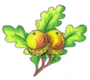  Year 6  Summer Term  Discussion map  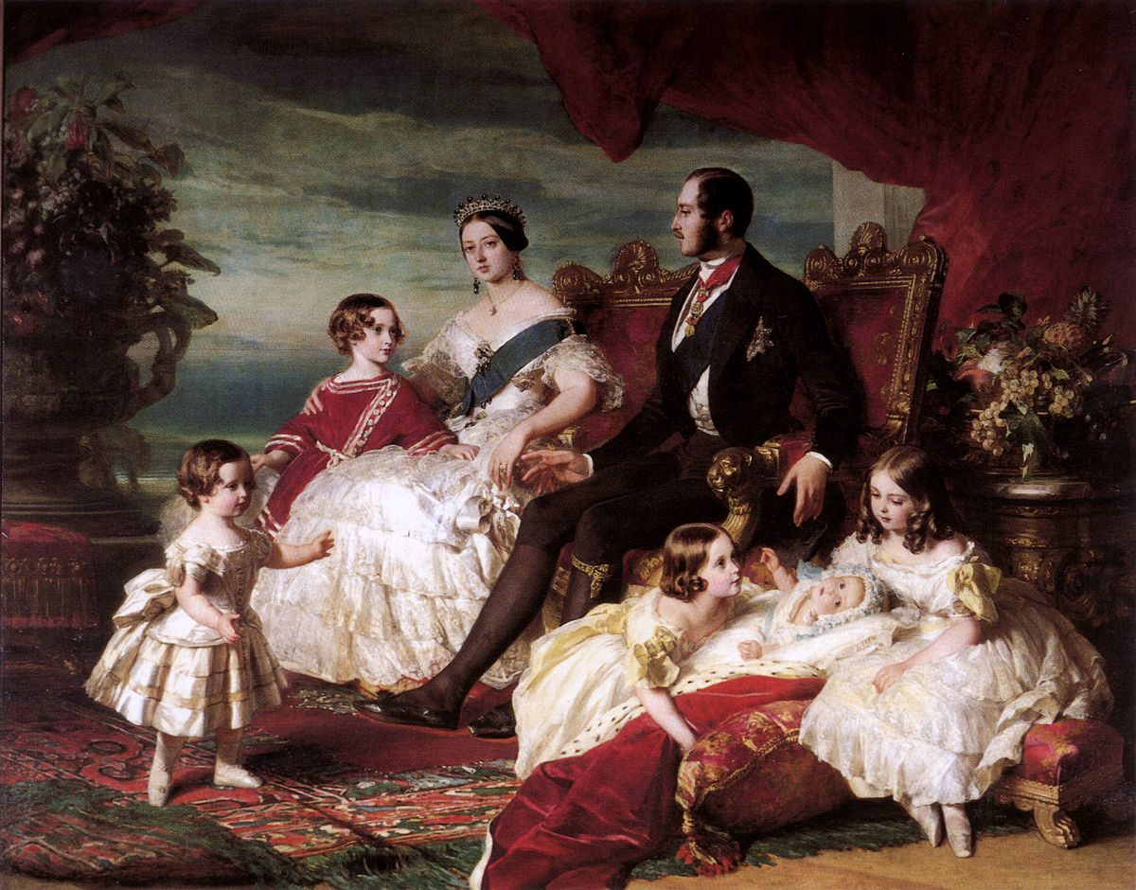  Here are some questions and vocabulary that we hope your child will be able to answer by the end of our work in school this term.  You can also use them as discussion points to find out more about what they have been learning in school. | Science – Living Things in their Habitats
Facts | When did the Victorian period begin and end? |  |  |  |  | Facts | How and why are all living things classified on our planet?
 | What can you tell me about Queen Victoria?
 | What was the Industrial Revolution? |  |  |  |  |  | Who was Carl Linneaus?
 | Can you name some important inventions from the Victorian era? |  |  |  |  |  | What is The Linneaus System?
 | What improvements were made to health, disease and medicine during Victorian times? |  |  |  |  |  | What does a taxonomist do?
 | What did rich and poor Victorians do during their leisure time? |  |  |  |  |  | What is a dichotomous key?
Vocab | arithmetic  industry  Industrial  Revolution | invention  migrate  reign  livestock | rural  revolution typhoid  workhouse |  |  | Vocab | characteristics  classify  taxonomist  key | The Linnaeus System  Carl Linnaeus |  | microorganism  species  vertebrate  bacteria invertebrate
Geography - The Water Cycle |  |  |  |  |  | DT – Cooking and Nutrition
Facts | What is evaporation and can you explain its part in the water cycle? |  |  |  |  | Skills | What are the five different food groups?
 |  |  |  |  |  |  | How many portions of each food group should we eat to have a healthy and varied diet?
 | What is condensation and can you explain its part in the water cycle? |  |  |  |  |  | Why is it important to use seasonal produce and consider sustainability when cooking?
 | How do clouds form? |  |  |  |  |  | How can we stay safe when cooking?
Vocab | sun  sea  rivers  streams  source |  |  | run off  ground water  precipitation  condensation  evaporation |  | Vocab | healthy & varied  diet  food/meal plan  calories  saturated fat |  | adding/substituting seasonal produce  seasonality  sustainability  health & safety

