History - Crime and Punishment |  |  |  |  | 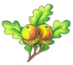  Year 5  Summer term  Discussion map  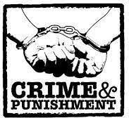  Here are some questions and vocabulary that we hope your child will be able to answer by the end of our work in school this term.  You can also use them as discussion points to find out more about what they have been learning in school.  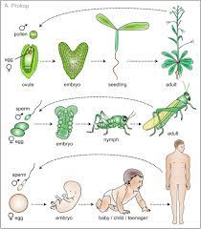 | Geography – mapping
Facts | What is a crime and how have crimes changed since the Roman times? |  |  |  |  | Facts | Why do maps have symbols on them? Which map symbols can you recognise?
 | How have criminals been punished in the past? |  |  |  |  |  | Could you find a location using four-figure co-ordinates?
 | Can you compare modern crime prevention/ detection methods to those from the past? |  |  |  |  |  | How many UK counties and cities can you locate?
Vocab | peelers  deterrent  execution  highwayman  humiliation | judge  jury  victim  treason  trial |  | the rack  treadwheel  ducking stool  ordeal punishment  fingerprints |  | Vocab | compass  Ordnance Survey map  key  co-ordinates |  | human features  physical features  NW  grid reference
Science – Living Things & Their Habitats / Animals including Humans |  |  |  |  |  | DT – Alarms
Facts | Why do all living organisms, including plants, reproduce? |  |  |  |  | Skills | Can you build a simple circuit to protect an object from an intruder?
 | Can you describe the process of reproduction in mammals? |  |  |  |  |  | Can you make a prototype of your design?
 | What are the 6 different stages of human development? |  |  |  |  |  | How can we make the joints more reliable?
Vocab | life cycle  sexual reproduction  asexual reproduction  mammal |  | fertilise  gestation  metamorphosis  pollination |  |  | Vocab | prototype  circuit  switch  sensor | input  output  alarm  solder

