History – Famous Monarchs |  |  |  | 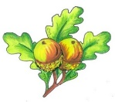  Year 3  Summer term  Discussion map  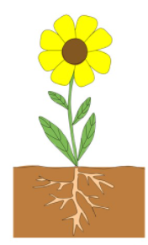  Here are some questions and vocabulary that we hope your child will be able to answer by the end of our work in school this term.  You can also use them as discussion points to find out more about what they have been learning in school. | Geography
Facts | What is a monarch? |  |  |  | Facts | A cartographer is someone who draws or produces maps.
 | Did Mary deserve her nickname? |  |  |  |  | 90% of land in the UK is rural
 | What is Henry VIII known for? |  |  |  |  | Human geography is things that are manmade whereas physical geography is natural.
Vocab | Battle of Bosworth  Heir  Annul  Reign | Treason  Monarch  Execution  Reformation | Divorced Beheaded  Catholic  Protestant |  | Vocab | Agricultural  Countries  Recreational  Retail | Rural  Symbol  Urban
Science – Plants |  |  |  |  | PE – Striking and fielding
Facts | What do plants and seeds need to grow healthily? |  |  |  | Skills | I can determine what kind of shot to play depending on the situation.
 | What are the functions of the different parts of a plant? |  |  |  |  | I know how to brush the ground with the back of the club to get the ball into the air.
 | How is water transported through plants? |  |  |  |  | I can adjust my swing to the distance I want to hit the ball.
Vocab | Pollen  Fertilisation  Nectar  Dispersal | Nutrient  Photosynthesis  Germination  Stamen | Carpel  Dispersal  All the parts of a plant and a flower. |  | Vocab | Runs  Wickets  Stance  Grip  Fielding | Par  Pitch  Putt  Posture  Eye contact

